Medication Adherence
Communication from the URI Pharmacy Outreach Team!

What is Medication Adherence?
Medication adherence is making sure you are taking your medication the right way – as directed by your doctor. It is important to stay adherent to your medications because it prevents symptoms from coming back or worsening, keeps you out of the hospital, and keeps you living a long, full life.

Ways to stay adherent to your medications:

- Keep a list of your medications with the name of drug, the dose, and when you take it each day (you can even ask your pharmacy to provide you with this list!)
- Use a pill calendar or pill box/organizer – these are available at any local pharmacy!
- Create a routine – take the medications at the same time or after the same activity every day

How do I ask for medication delivery?
Many pharmacies are offering prescription delivery directly to your house or apartment. You can enroll for this online on your pharmacy’s website or CVS has an app for your phone allowing you to refill your prescriptions & enroll in delivery with a touch of the screen. You can always ask your pharmacy team about medication delivery or for help with enrolling.
If you are worried about getting sick and would prefer to pick up your medications yourself, using the pharmacy’s drive-thru window is always available.
How to protect yourself from COVID-19:
- Wash your hands often with soap and water for at least 20 seconds!
- Avoid touching your face.
- Keep a safe distance from others (at least 6 feet).
- Stay home if you can! :)
Did you know??? You can call ahead at your pharmacy to purchase over-the-counter items at the drive-thru window!

Reasons for missing doses:

1. We’re human, so the most common reason is forgetting

2. Cost – Medications can be expensive, so ask about coupons and cost-saving strategies

3. Side Effects – Serious or bothersome side effects may prevent people from taking their prescriptions
To read the latest information about coronavirus (COVID-19) in Rhode Island, visit the Rhode Island Department of Health website:
https://health.ri.gov/covid
or call the
COVID-19 Info Line at 401-222-8022

 |  | 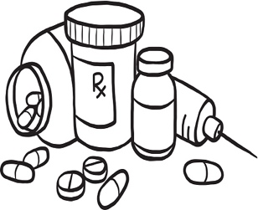 | Wash your hands, cough into your elbow, don’t touch your face, keep a safe distance, and stay home if you can

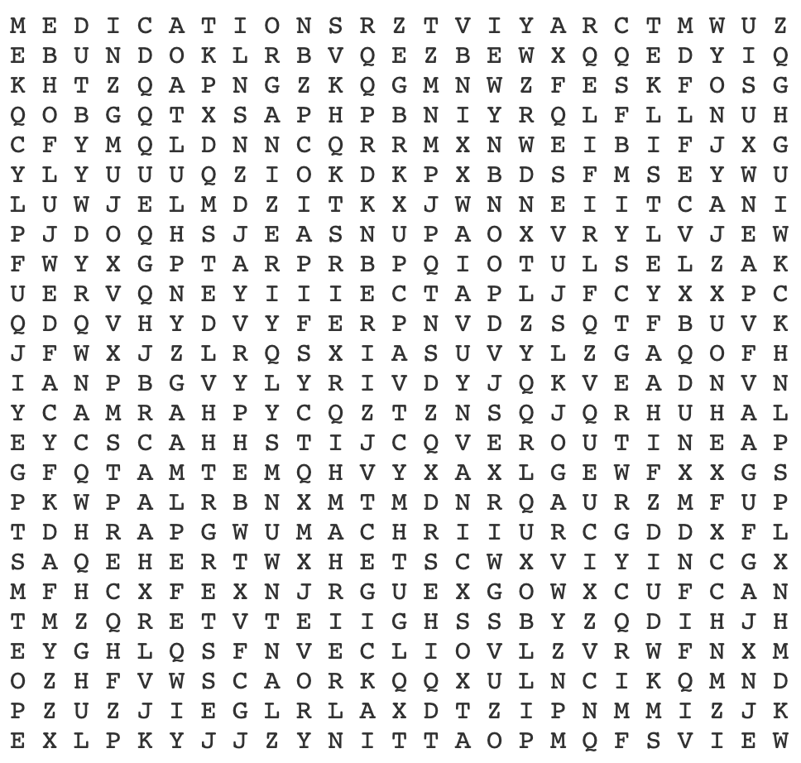
Medication Adherence
Word Search
Prepared by: Kristen St. Jean and Brad Williamson, PharmD Candidates Class of 2020
Preceptor: Nancy Tortolani
ADHERENCE MEDICATIONS PRESCRIPTIONS
CALENDAR ORGANIZER REFILL
HEALTHY PHARMACY REMINDERS
LIST PILLBOX ROUTINE

